Feasibility Report

“Distributed Computing and Parallel Processing-Based Live Video Surveillance”



Project By
Abdul Jalil Jadoon
FA13-BCS-001
Fahama Babar Khan
FA13-BCS-029
Muhammad Rohan Ali
FA13-BCS-051

Supervised by
Dr. Osman Khalid
Co-Supervised by
Dr. Muhammad Usman Shahid

Table of Content

1. Title: " Computing and Parallel Processing-Based Live Video Surveillance“ 3
2. Introduction 3
3.Functional Requirements: 3
4. Block Diagram: 3
5.Non-Functional Requirements: 4
6.Feasibility Analysis: 4
6.1Technical Feasibility: 5
6.2Financial Feasibility: 5
6.3 Resource Feasibility: 5
6.4 Schedule feasibility: 6
6.5Operational Feasibility: 6
7.Assumptions: 6

1. Title: " Computing and Parallel Processing-Based Live Video Surveillance“

2. Introduction
Security and safety is an important aspect in governmental organizations as well as non-governmental organizations. Usually most organizations use classical video surveillance systems in which no advance technique or intelligence is involved. Classical systems usually fail to stop an incident because no alert is generated. When the human is actively monitoring all the screens then it is possible to take necessary action but usually this requires more resources. Humans cannot actively monitor all screens at a time, human may fall asleep, due to tiredness he may not be able to analyze all activates on the screen. So Video Surveillance can observe and analyze the specific area for safety purpose.
A distributed system is a model in which components located on networked computers communicate and coordinate their actions by passing messages.
Parallel processing is the processing of program instructions by dividing them among multiple processors with the objective of running a program in less time
The objective of this project is to automate live video surveillance by providing better safety and security via technology through parallel processing and distributed computing
This project will detect a face of the anomaly from live video if a person enters in specific place than regular threshold , it will generate alarm and it also convey message to some authorized person through messaging . We shall be using multiple Raspberry Pi’s to build a distributed computing network (Cluster) and Parallel processing will be applied to reduce response time.

3.Functional Requirements:

3.1 Distributed Computing Cluster and Parallel Processing:
Distributed Computing network will be created with a cluster of Raspberry Pi’s to cope with complexity and provide more processing power. Tasks shall be distributed in distributed network of Raspberry Pi’s and executed parallel for better response time. As a programming language we will use Python and as for programming in parallel, we will use MPI library.

3.2 Face Detection
During the live video streaming we will detect the face and for the detection of face
We will use the Class that is CascadeClassifier .

3.3 Face Recognition:
Face recognition in live streaming is one of the main feature that shall be further used. OpenCv library will be used for face recognition.OpenCV 3.1 now comes with the very new FaceRecognizer class for face recognition.

3.4 Detection of Frequent visit Anomaly:
If a person enters a specific place and when the provided visit threshold is exceeded then the alert will be generated . Usually before doing any suspicious activity such people frequently monitor and visit the place.

4. Block Diagram:

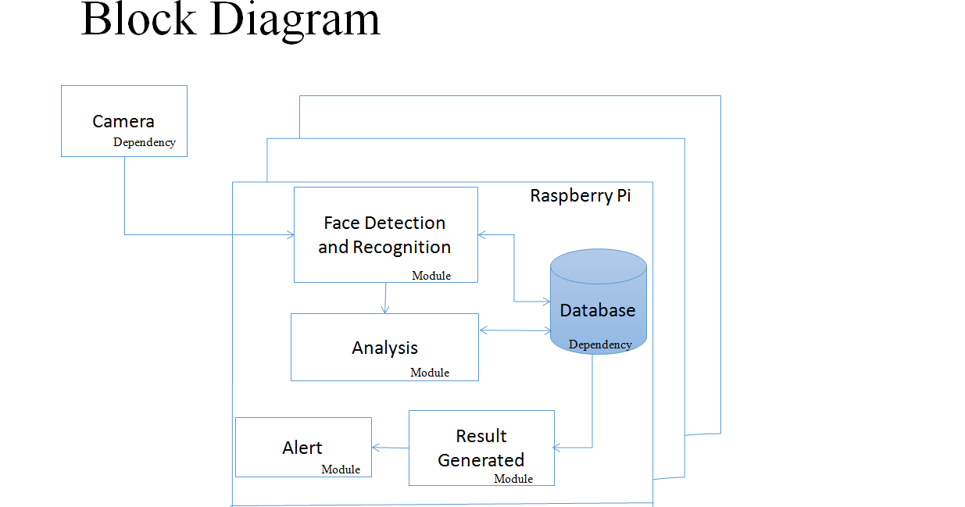

5.Non-Functional Requirements:

5.1 Performance Requirements
- Deploy in small organization because we will use 3 raspberry pi’s and one camera
- The performance can be improve by using more raspberry pi’s but we are using only 3 raspberry pi for parallel processing
- For better performance we are using the Raspberry pi 3 model.

5.2 Safety and Security Requirements
- Used by governmental organizations and as well as privately held companies to enhance their security.
- Attack could be stopped in future or at least the damage could be reduced by using our project.

5.3 Software Quality Attributes
- The product provide very secured environment to the organization
- The product is easily portable due to Raspberry pi .

6.Feasibility Analysis:
An overall study of the project has been carried out and the findings have been listed in this report. The feasibility of “Distributed Computing and Parallel Processing-Based Live Video Surveillance” can be ascertained on the following assessments:
- Technical feasibility
- Financial feasibility
- Resources feasibility
- Schedule feasibility
- Operational feasibility (if applicable)

6.1Technical Feasibility:
Technically this project is feasible. Tools are available online. OpenCv library shall be used for detecting and recognizing faces. MySql will be used to store data. Raspberry Pi 3 is already purchased. Raspberry Pi 3 supports various operating systems for example: windows 10 IoT, raspbian, ubuntu mate, etc. We will use Raspbian OS because it is officially supported & based on Debian OS. We also searched whether is it possible to run Opencv on Raspberry pi ? Can we build a cluster? Answers to these questions were positive. Raspberry pi 3 is powerful enough for image processing. Detecting a face is possible in opencv and for this we will use its class CascadeClassifier. Recognizing the face is also possible in opencv for this purpose we will use class FaceRecognizer.

6.2Financial Feasibility:

Resource Name  [hardware or software] | Price  [Monetary cost] | Source  [website URL/Dealer's address etc.]
Raspberry Pi 3 (x3) with SD Card | 16,000 | instock.pk
Camera | 1,500 | Locally Market
Keyboard, Mouse, LCD | Already available | Self
Switch | Rs 850 | Local Market
Ethernet Cables | Already Available | Self
Raspberry Pi Official Charger(x3) | 4,500 | Instock.pk
Sponsors/ Funding sources | Self

6.3 Resource Feasibility:
Raspberry pi 3 will be bought form instock.pk. But they are also available in local market. Other hardware accessories are already purchased. Software and libraries are openly available free of cost. OpenCV is free of cost and the operating system Raspbian based on Debian is also available free of cost online.
OpenCV: http://opencv.org/
Raspbian: www.raspberrypi.org/downloads/

6.4 Schedule feasibility:

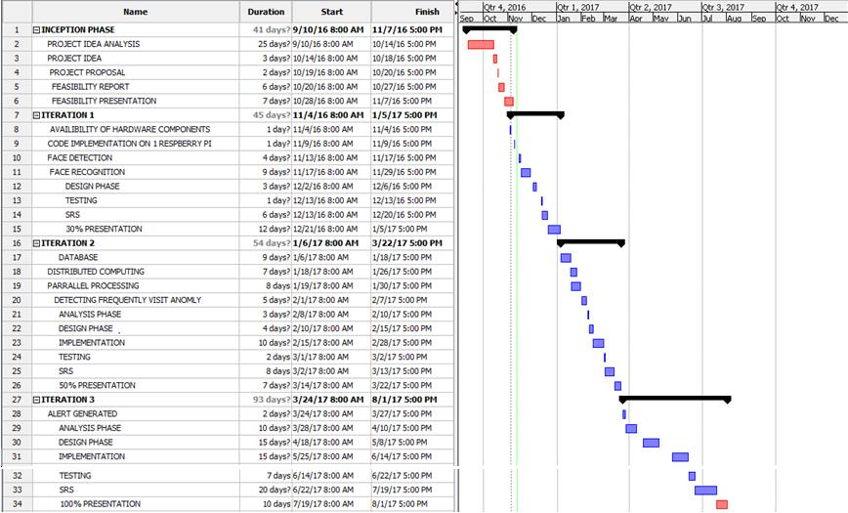

6.5Operational Feasibility:
Our project is a real world implementation and it can be used by governmental organizations and as well as privately held companies to enhance their security. Due to distributed computing and raspberry pi’s the project is cost effective and we can add more pi’s to give more processing power. Our system will use 3 raspberry pi’s and one camera which in other words is for small organization.

7.Assumptions:
  - The Hardware component must be arrange properly
  - Good lighting conditions are necessary for face detection and recognition
  - Our project does not detect the person who’s face is covered

